Future AGI Planning

# Clamp Based Code Snippets

Given your experience with responsive design, there are several other CSS clamp() applications that would create valuable WordPress snippets for the developer community:

**Container & Layout Snippets:**

* **Container max-widths** - clamp(320px, 90%, 1200px) for responsive containers that adapt gracefully across devices
* **Sidebar widths** - clamp(250px, 25%, 350px) for flexible sidebar layouts
* **Grid gaps** - clamp(1rem, 4vw, 3rem) for responsive spacing in CSS Grid layouts

**Media & Visual Elements:**

* **Image sizing** - clamp(150px, 50vw, 400px) for responsive images that maintain aspect ratios
* **Logo sizing** - clamp(120px, 15vw, 200px) for headers that scale appropriately
* **Icon dimensions** - clamp(16px, 2.5vw, 32px) for consistently readable icons
* **Border radius** - clamp(4px, 1vw, 12px) for buttons and cards that feel proportional

**Interactive Components:**

* **Button padding** - clamp(0.5rem, 2vw, 1.5rem) for touch-friendly buttons across devices
* **Form input heights** - clamp(40px, 5vw, 60px) for accessible form controls
* **Navigation spacing** - clamp(1rem, 3vw, 2.5rem) for menu items

**Specialized Applications:**

* **Video/iframe responsive sizing** - For embedded content that maintains proportions
* **Card component dimensions** - For product grids or blog layouts
* **Hero section heights** - clamp(50vh, 75vh, 100vh) for impactful hero areas

I'd suggest these as logical next calculator products:

**1. Container Clamp Calculator** This would be a strong standalone product covering:

* Container max-widths
* Sidebar/aside widths
* Content area sizing
* Grid/flexbox container dimensions

The value proposition is that container sizing is foundational to every responsive layout, and getting the proportions right across breakpoints is always tricky.

**2. Media Clamp Calculator** Another solid product for:

* Image responsive sizing
* Logo scaling
* Icon dimensions
* Video/iframe proportional sizing

This addresses the universal challenge of media that looks good on phones without being tiny on desktops.

**3. Component Clamp Calculator** For interactive elements:

* Button padding and sizing
* Form input dimensions
* Card component proportions
* Navigation element spacing

This could be positioned as the "UI component" calculator.

**Layout Clamp Calculator** might work too, focusing specifically on:

* Grid gaps
* Flexbox spacing
* Section padding
* Layout-specific measurements

I'd prioritize **Container** and **Media** calculators first - they solve the most universal problems that every developer faces. The Container Calculator especially would complement your existing Font and Space calculators perfectly, since those three cover the core responsive design trinity: typography, spacing, and layout containers.

* Additional WordPress Ideas for Code Snippets  
  **Breakpoint Debugger** - Visual overlay showing current breakpoint, viewport size, and device orientation
* **Grid Overlay Generator** - CSS snippet to add temporary grid lines for alignment checking
* **Aspect Ratio Calculator** - Generate CSS for responsive containers maintaining specific ratios
* **Safe Area Generator** - CSS for mobile notch/safe area handling

**Layout & Positioning Tools:**

* **Flexbox Helper Classes** - Pre-built utility classes for common flex patterns
* **Z-Index Manager** - Organized z-index scale system with named layers
* **Sticky Position Calculator** - Generate proper sticky/fixed positioning CSS
* **Object-Fit Optimizer** - Smart image fitting for various container shapes

**Performance Optimization:**

* **Critical CSS Extractor** - Identify above-the-fold styles for performance
* **Lazy Load Snippet Generator** - Custom lazy loading implementations
* **Font Display Optimizer** - Generate font-display strategies for web fonts
* **Image Optimization CSS** - Responsive images with proper sizing

**Animation & Interaction:**

* **CSS Animation Builder** - Generate keyframe animations with easing curves
* **Hover State Generator** - Consistent hover effects across elements
* **Scroll Trigger CSS** - Intersection Observer-based animations
* **Loading State Templates** - Skeleton screens and loading animations

**Elementor/Bricks Specific:**

* **Custom CSS Injector** - Organized system for adding custom styles per element
* **Icon Font Optimizer** - Subset icon fonts to only used icons
* **Color Palette Manager** - CSS custom properties system for brand colors
* **Typography Scale Generator** - Consistent text sizing beyond basic clamp

**Developer Workflow:**

* **CSS Reset Modernizer** - Updated normalize/reset specifically for page builders
* **Debug Mode Toggle** - Quick enable/disable development helpers
* **Cross-Browser Fallback Generator** - Automatic fallbacks for modern CSS
* **Print Stylesheet Generator** - Print-optimized styles for web content

**Accessibility & SEO:**

* **Focus Indicator Generator** - Consistent, accessible focus styles
* **Screen Reader Optimizer** - Hidden content and aria-label helpers
* **Semantic HTML Enhancer** - Proper heading hierarchy and landmark roles

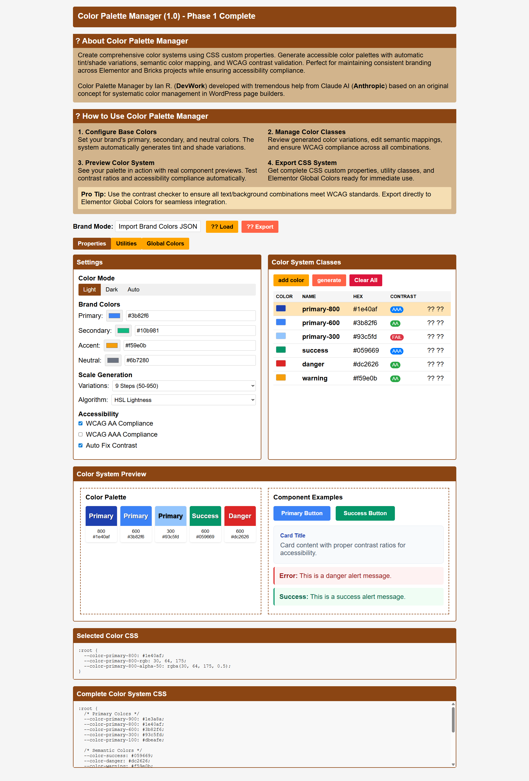

## Thoughts on Color Palette Manager

**Color Palette Manager - CSS Custom Properties System**

This would generate a comprehensive color system using CSS custom properties, perfect for Elementor/Bricks workflows:

**Core Features:**

* **Brand Color Hierarchy** - Primary, secondary, accent, neutral scales with automatic tint/shade generation
* **Semantic Color Mapping** - Success, warning, error, info colors that reference brand colors
* **Dark/Light Mode Toggle** - Automatic color scheme switching with proper contrast maintenance
* **Accessibility Validator** - Real-time WCAG contrast checking between text/background combinations
* **Alpha Variation Generator** - Automatic transparency variants (10%, 20%, 50%, etc.) for overlays and subtle backgrounds

**Practical Output:**

css

:root {

*/* Brand Colors */*

--color-primary-900: #1a2332;

--color-primary-500: #3b82f6;

--color-primary-100: #dbeafe;

*/* Semantic Colors */*

--color-success: var(--color-green-500);

--color-danger: var(--color-red-500);

*/* Component Colors */*

--button-primary: var(--color-primary-500);

--button-hover: var(--color-primary-600);

}

**Elementor/Bricks Integration:**

* Export palette as Global Colors for direct import
* Generate utility classes (.bg-primary, .text-accent)
* Create component-specific color maps
* One-click copy for custom CSS sections

## Thoughts on Typography Scale Generator

**Typography Scale Generator - Complete Typography System**

This goes far beyond your font clamp calculator to create a complete typographic system:

**Advanced Features:**

* **Modular Scale Calculator** - Perfect fifth, golden ratio, or custom ratio-based sizing
* **Line Height Harmony** - Automatic line-height calculation maintaining vertical rhythm
* **Font Weight Mapping** - Organized weight system (light: 300, regular: 400, bold: 600)
* **Responsive Typography Matrix** - Font size + line height + letter spacing all scaling together
* **Component Typography** - Pre-defined styles for buttons, headings, body text, captions

**Smart Relationships:**

css

:root {

*/* Base Scale */*

--text-xs: clamp(0.75rem, 0.5vw + 0.6rem, 0.875rem);

--text-sm: clamp(0.875rem, 0.7vw + 0.7rem, 1rem);

--text-base: clamp(1rem, 1vw + 0.8rem, 1.125rem);

*/* Automatic Line Heights */*

--leading-xs: calc(var(--text-xs) * 1.4);

--leading-sm: calc(var(--text-sm) * 1.5);

*/* Component Styles */*

--heading-h1: var(--text-4xl);

--heading-line: var(--leading-tight);

--body-text: var(--text-base);

--body-line: var(--leading-relaxed);

}

**Typography Relationships:**

* **Vertical Rhythm Grid** - Ensures all text aligns to a baseline grid
* **Optical Sizing Adjustments** - Automatic letter-spacing tweaks for larger text
* **Reading Optimization** - Line length calculations for optimal readability
* **Font Pairing Guidance** - Suggests scale adjustments when mixing fonts

**Output Formats:**

1. **CSS Custom Properties** - For maximum flexibility
2. **Utility Classes** - .text-lg, .leading-relaxed for quick application
3. **Component Classes** - .heading-1, .body-copy, .caption for semantic use
4. **Elementor Global Fonts** - Direct import format
5. **Design Token JSON** - For design system documentation

**Practical Workflow Integration:**

* **Live Preview Mode** - See typography scaling across breakpoints
* **Content Testing** - Preview with real headlines, paragraphs, lists
* **Accessibility Scoring** - Readability analysis and font size recommendations
* **Brand Consistency Checker** - Ensure typography aligns with brand guidelines

**Advanced Calculator Features:**

* **Font Loading Optimization** - Generate font-display and preload strategies
* **Variable Font Support** - Leverage font-weight and font-stretch axes
* **Fallback Font Stacking** - Smart system font fallbacks
* **Print Typography** - Separate scaling for print media queries

